**Task 2: Implement conditional, control and looping statements**

**AIM**

To implement conditional , control and looping statements using python

1. **You are developing a simple grade management system for a school. The system needs to determine the grade of a student based on their score in a test. The grading system follows these rules:**

**If the score is 90 or above, the grade is "A".**

**If the score is between 80 and 89, the grade is "B".**

**If the score is between 70 and 79, the grade is "C".**

**If the score is between 60 and 69, the grade is "D".**

**If the score is below 60, the grade is "F".**

**ALGORITHM**

1. Start
2. Get the input mark from the user.
3. With the use of an If-elif-else statement do

* If the marks>=90 print grade “A”.
* If the mark is between 80 and 89 print grade “B”.
* If the mark is between 70 and 79 print grade “C”.
* If the mark is between 60 and 69 print grade “D”.
* If the mark is below 60, print grade “F”.

1. Stop

**PROGRAM**

score =int(input("Enter the score:"))

if score>=90:

print("The Grade is A")

elif (score <=89 and score>=80):

print("The Grade is B")

elif(score <=79 and score >=70):

print("The Grade is C")

elif( score <=69 and score >=60):

print("The Grade is D")

else:

print("The Grade is F")

**Output:**

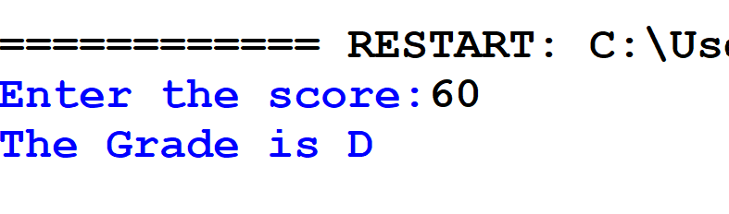

1. **You are developing an educational program to help young students learn about natural numbers. One of the features of the program is to display the first 10 natural numbers to the user. Write a Python program that uses a for loop to print the first 10 natural numbers.**

**ALGORITHM**

1.Start.

2.Display “The first 10 natural numbers are:”.

3.Use a for loop for generating the numbers.

4.Print the output.

5.Stop

**PROGRAM**

# Displaying the first 10 natural numbers

print("The first 10 natural numbers are:")

for i in range(1, 11): # Loop from 1 to 10

print(i)

**Output:**

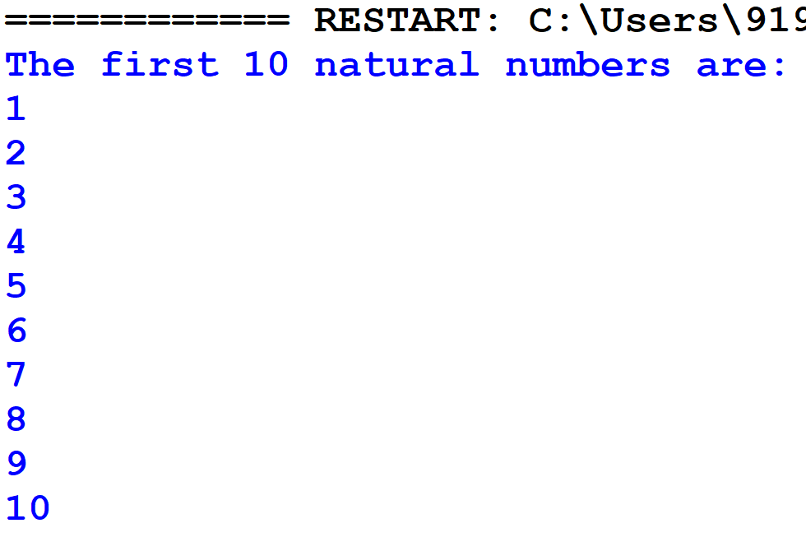

1. **You are working on a feature for a financial application that involves validating user input. One of the requirements is to count the total number of digits in a given number**

**ALGORITHM**

1.Start.

2. get the input from the user.

3.Convert the integer to string using str().

4.Use len function to find number of digits.

5.Print the output.

**PROGRAM**

digit=int(input("Enter the Number:"))

string=str(digit) #since integer doesn't have len()

count=len(string)

print("The number of digits in ",digit,"is :",count)

**Output**:

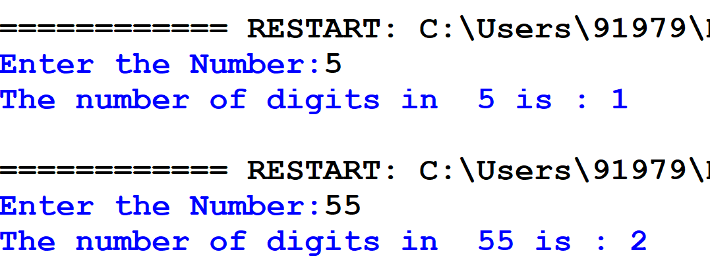

**RESULT**

Thus, the python program to implement conditional, control and looping statements was done successfully.